**Name:- Prathmesh Patil**

**AIIT (BCA SEM 4)**

**A71004819033**

**ASSIGNMENT:-1**

**Introduction:-**

**Business intelligence (BI) :-** Business intelligence (BI) is a technology-driven process for analyzing data and presenting actionable information which helps executives, managers and other corporate end users make informed business decisions. BI encompasses a wide variety of tools, applications and methodologies that enable organizations to collect data from internal systems and external sources, prepare it for analysis, develop and run queries against that data and create reports, dashboards and data visualizations to make the analytical results available to corporate decisionmakers, as well as operational workers. Other potential benefits of business intelligence tools include: • accelerating and improving decision-making; • optimizing internal business processes; • increasing operational efficiency; • driving new revenues; • gaining competitive advantage over business rivals; • assisting companies in the identification of market trends; and • spotting business problems that need to be addressed

**INSTALLATION:**

1. SQl Server Management Studio (SSMS)

First we have to go on official site of Microsoft

<https://docs.microsoft.com/en-us/sql/ssms/download-sql-server-management-studio-ssms?view=sql-server-ver15>

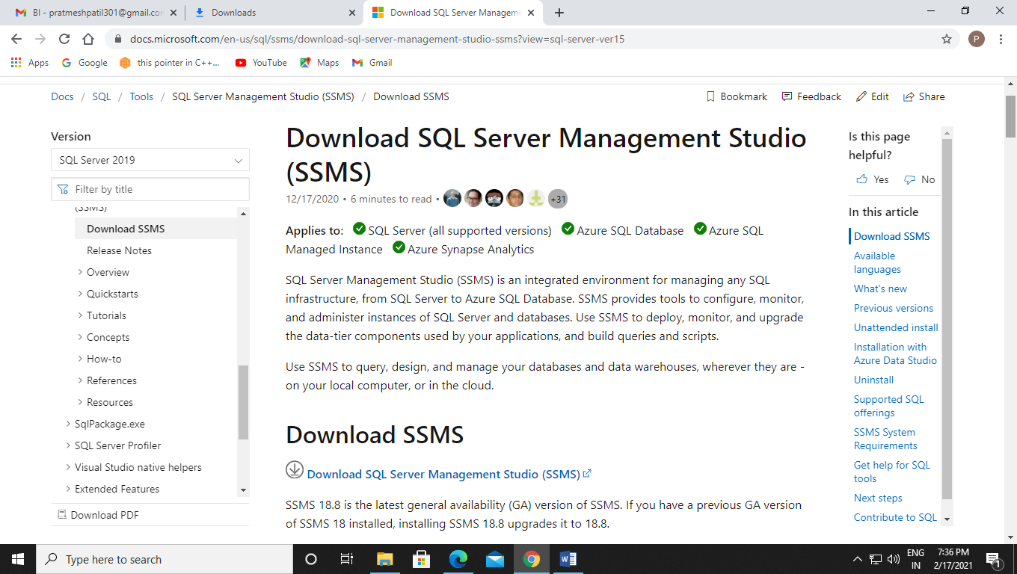

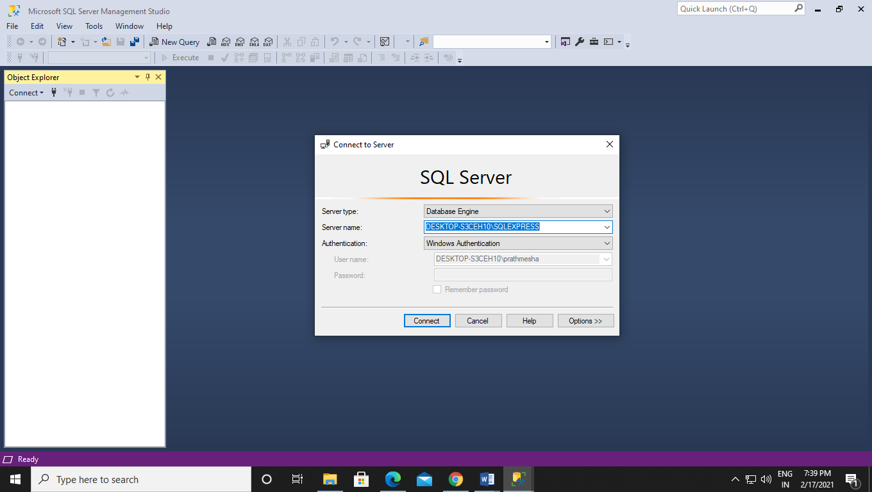

Then we have to connect it from our server name.



1. SQL Server Data Tools (SSDT)

First we have to go on official website of Microsoft

<https://docs.microsoft.com/en-us/sql/ssdt/download-sql-server-data-tools-ssdt?view=sql-server-ver15>

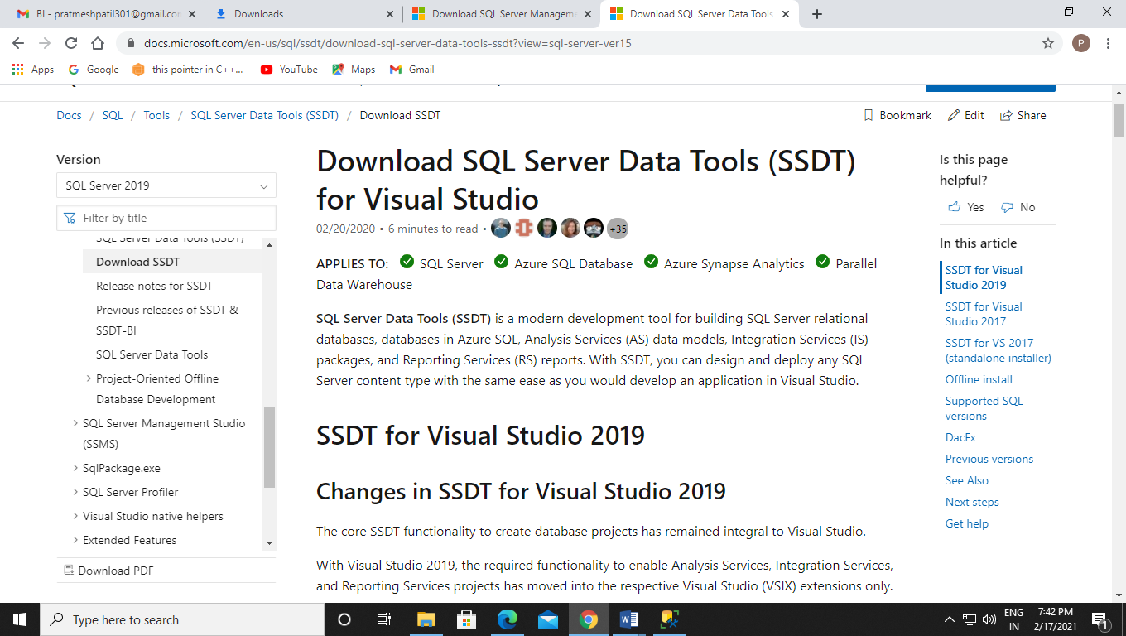

Here we have to download Data Storage and Processing :-

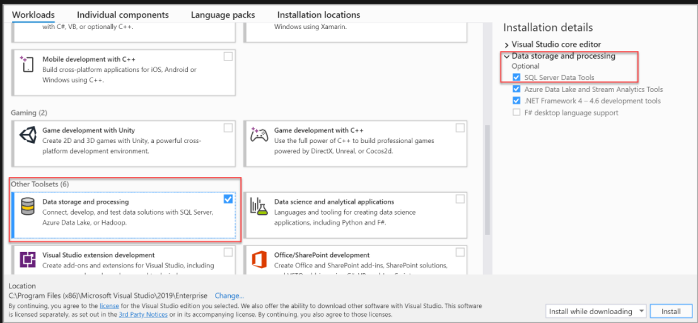

Now we have to make our project folder.

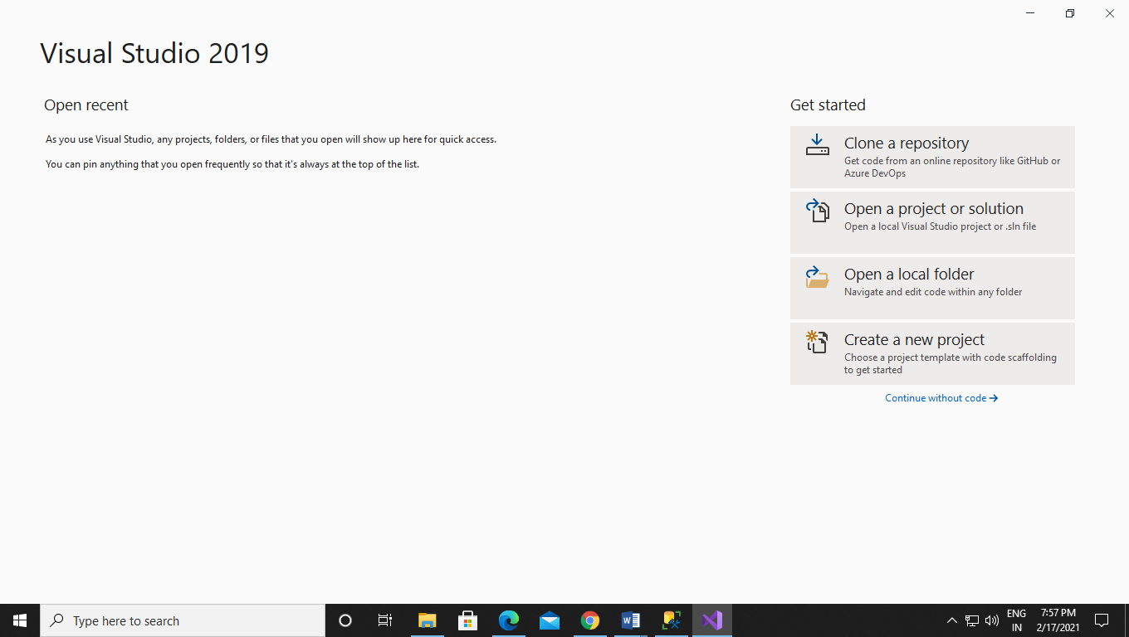

1. Analysis Services:-

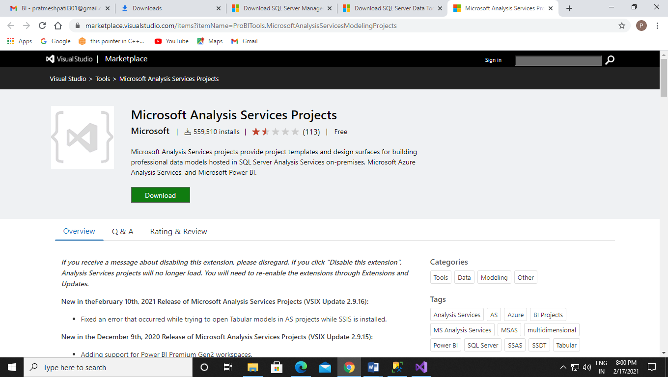

1. Integration Services:-

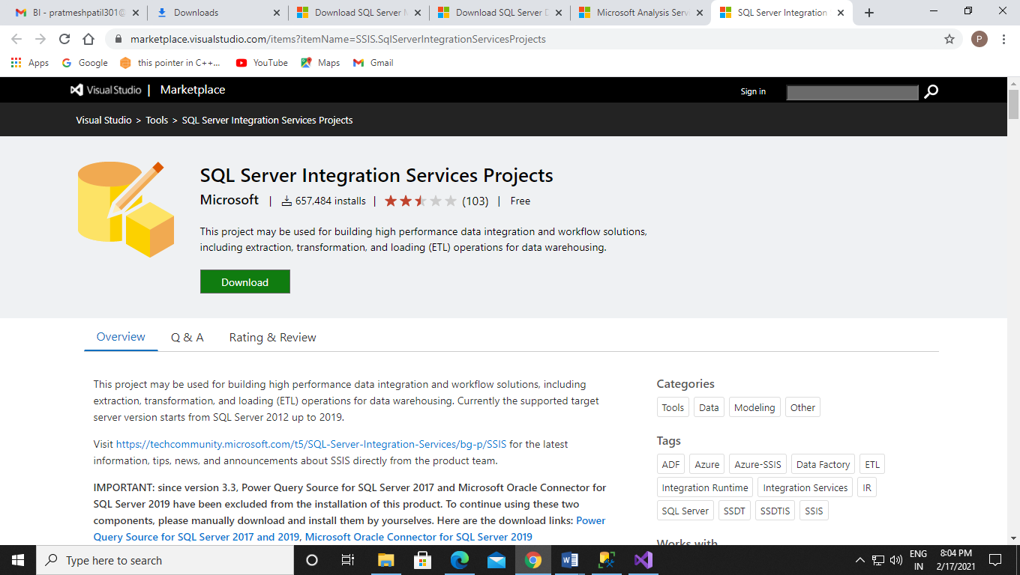

1. Reporting Services:-

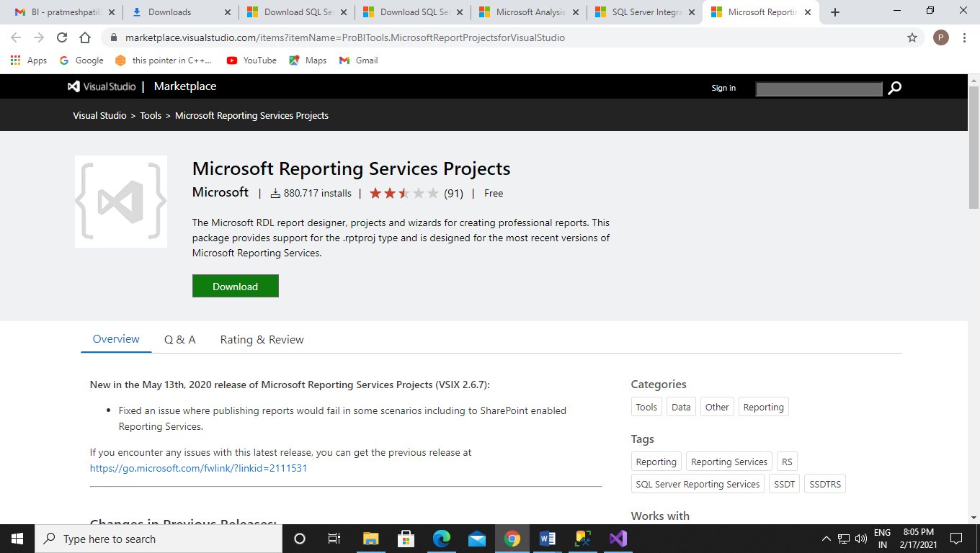

These are the tools which is require for SSMS.